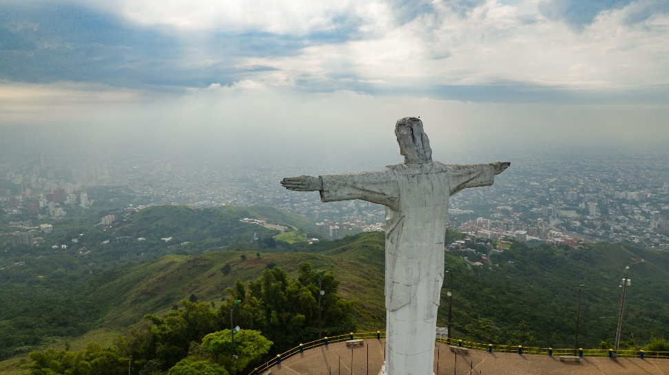

History of Christ the Redeemer

Christ the Redeemer is an iconic statue located in Rio de Janeiro, Brazil. Here are eight key points about its history:

**1. \*Concept and Design (1920s):\*** The idea for Christ the Redeemer was conceived in the early 1920s by a group of Brazilian Catholics who wanted to build a religious monument overlooking the city of Rio de Janeiro. They organized a competition to design the statue.

**2. \*Art Deco Design:\*** The winning design for the statue was created by Brazilian engineer Heitor da Silva Costa and sculpted by French artist Paul Landowski. The statue was designed in the Art Deco style, which was popular at the time.

**3. \*Construction (1926-1931):\*** The construction of Christ the Redeemer began in 1926 and took approximately five years to complete. The statue was built on the summit of Mount Corcovado, which stands at 2,310 feet (704 meters) above sea level in the Tijuca Forest National Park.

**4. \*Materials:\*** The statue is made of reinforced concrete and covered with soapstone tiles. The soapstone tiles were chosen for their durability and resistance to the elements.

**5. \*Inauguration (October 12, 1931):\*** Christ the Redeemer was officially inaugurated on October 12, 1931. The date also coincided with the 100th anniversary of Brazil's independence from Portugal. The statue was a gift from the Catholic community to the city of Rio de Janeiro.

**6. \*Symbolism:\*** Christ the Redeemer is a symbol of Christianity and a representation of Jesus Christ's open arms, welcoming all who come to Rio de Janeiro. It is also seen as a symbol of peace and goodwill.

**7. \*World Heritage Site:\*** In 2007, Christ the Redeemer was designated as a UNESCO World Heritage Site, along with the surrounding Tijuca Forest National Park. The statue attracts millions of tourists from around the world each year.

**8. \*Restoration and Maintenance:\*** Over the years, the statue has undergone several restoration projects to repair weather-related damage and ensure its structural integrity. Ongoing maintenance efforts help preserve this iconic monument for future generations to enjoy.

Christ the Redeemer remains one of the most recognizable landmarks in the world and a significant symbol of both Rio de Janeiro and Brazil. Its towering presence atop Mount Corcovado offers breathtaking views of the city and serves as a testament to faith, artistry, and engineering.